Project Overview
You are a cyber security analyst working within a healthcare organization called Hospital X. Your Chief Information Security Officer has reached out to you with a new concern.
“A new healthcare legislation was announced this morning that negatively impacts millions of patients around the world, and masses are outraged. Soon after the announcement, three different hospitals in our partner network were hit with ransomware attacks that shut down their entire operations. The FBI believes that this is not the last in the string of hits. All hospitals should be prepared for a potential attack. I have two questions: Are we vulnerable to this threat? How should we respond?”

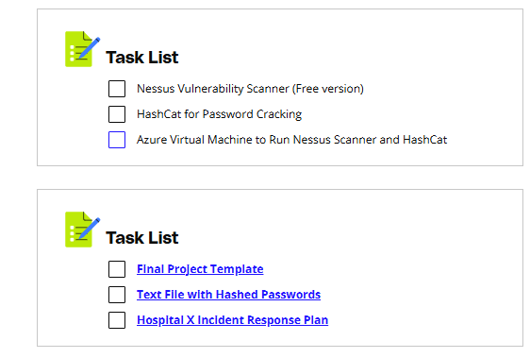
Project Steps

Please refer to the Grading Rubric for specifics for submission
- Review incident scenario content.
- Conduct research to understand what type of threat is involved, who is the actor behind the threat, and how they are motivated.
- Understand the vulnerabilities that were exploited within the other companies. Assess your assets and current mitigating controls to confirm if the threat could be relevant to your company.
- Conduct a vulnerability scan against your environment and confirm whether vulnerabilities are present. Attempt to exploit a weak password vulnerability. Make remediation recommendations.
- Outline the next steps required in response to the incident.
- Recommend improvements to the incident response plan to address gaps.
- Create a report for submission to the CISO that answers initial questions regarding the incident using the Final Project Template.

Project Deliverable
A report for presentation to the CISO answering the requested information.

Vulnerability Scanning Environment
LessonDownloads

Virtual Machine for the Project
For this project, you will practice on Udacity Cloud Lab. The VM have the necessary tools (such as Nessus) installed for you to practice your skills.

Pre-installed Nessus Credentials
Nessus is already pre-installed and running in the background in the Cloud Lab. In the VM above, search "Nessus web client" in the Windows Search bar. It will open https://localhost:8834/ in the Microsoft Edge browser.
Important Notes:
You can ignore the SSL warning by clicking Details and Go on to the website.* Use the following credentials when prompted:
Username: adnessus
Password: Ness@1234
Udacity Cloud Lab is the Virtual machine made available to you on the pages labeled "Cloud Lab - CYBERND0301". The VM in the Cloud Lab is actually running on the Azure cloud.
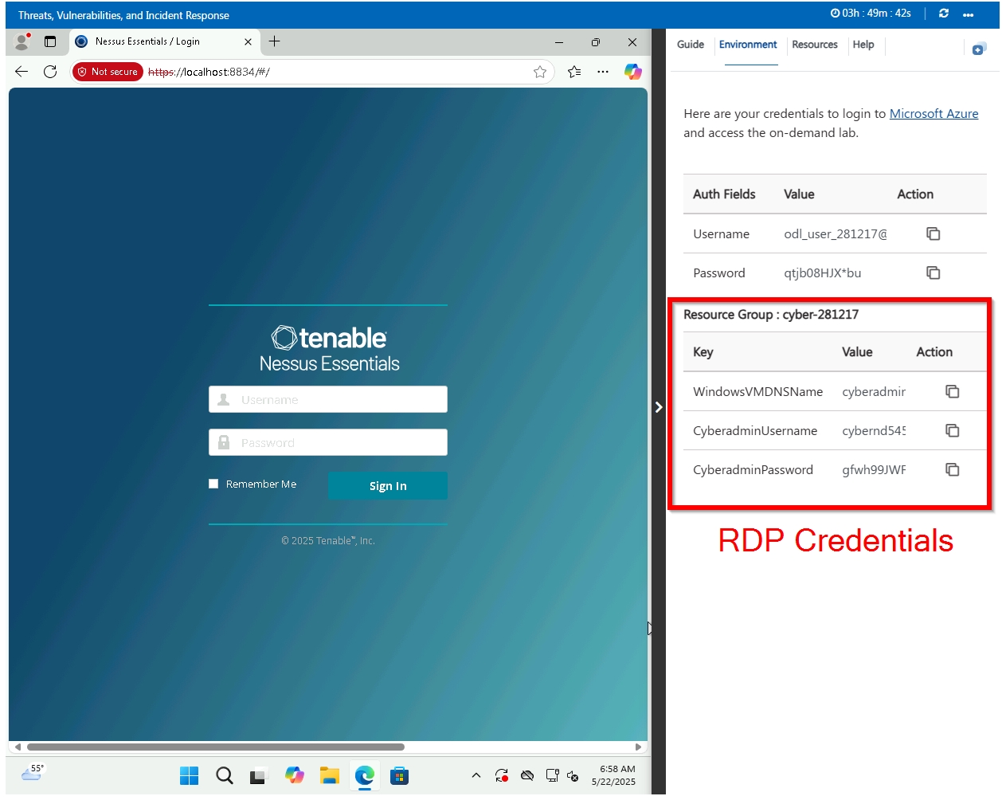
Cloud Lab - Win 11 Pro lab

Start the Cloud Lab VM
- Click on the ACCESS LAB button. Wait until the Cloud Lab loads (this could take up to 10 minutes)
- You can use the Cloud Lab VM in the classroom.
- You can also RDP into the VM if it's more convenient for you.

Known Issue in the Cloud Lab
While accessing the cloud lab VM in the browser, a problem with the keyboard input may occur, where the VM will not recognize the keystrokes from your local machine. As a result, you will not be able to type (write) any characters in the cloud lab VM.
As a workaround to resolve this issue, you can click somewhere on the Resource tab on the right collapsible pane and click back in the VM desktop, as shown in the snapshot below.

Restrictions
- Cloud Labs' session time is limited. Your session will expire after the validity expires, and you will lose all your resources in the temporary Azure account.
- Later, when you come back or refresh the Cloud lab page, you will get a new VM with a new pair of temporary credentials.
- You will not be able to create additional Resource Groups. There is one resource group already created for you named cloud-demo-XXXXXX. Choose the existing Resource Group when creating resources.
- You will not be able to create Active Directory resources. This is not a requirement for any project/exercise.
If you are not familiar with Azure, you can ignore the restriction points above.

First Update - 9:00am Monday
LessonDownloads

You’ve received the following details in a brief.
- Hospital A, Hospital B, and Hospital C each noticed that when trying to log into their centralized log management systems, the following message pops up.
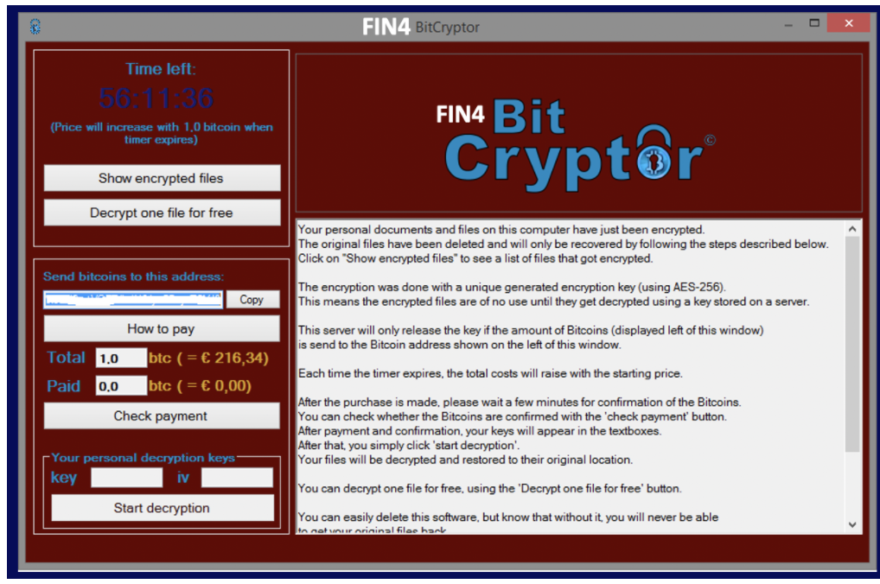
The ransomware note that pops-up on the infected log servers
- The hospitals have disclosed that each incident started with a user in the technology department opening an email attachment resource. This activity has not yet been seen in Hospital X.
Action: Conduct research to understand what type of threat could be involved, who is the threat actor behind the threat, and how they are motivated, and what attack tactics they are using or might use in the future. Add a threat profile to the report template. Follow the steps below to do so:
- Review the ransomware attack details provided by Hospital A, B, and C. Gain a understanding of the attack vector, specifically the ransomware message as shown in the image above and the method of entry.
- Conduct detailed research to identify the ransomware type used in the attacks. Determine the specifics of the ransomware, such as its encryption methods, demand specifics (e.g., bitcoin payment).
- Investigate potential threat actors and their motivations. Understand who is behind these attacks (state-sponsored, criminal gangs, hacktivists) and why they target healthcare institutions.Use the MITRE attack framework (opens in a new tab)to investigate the threat and threat actors.

Second Update - 11:00am Monday
LessonDownloads

- Five more hospitals report being targeted. All hospitals have a few things in common, including they all endorsed the new healthcare law that was passed. You’ve learned from your legal team that your hospital endorsed the law as well.
- They’ve noticed that the attackers are consistently targeting Windows systems that contain centralized log files and backups. They are also taking advantage of an unpatched Windows vulnerability to execute the attack.
- Tip: The IP address for your main log server is the IP address of your Azure virtual machine. You store all of your logs and backup logs in your data center on-site. Full backups are conducted once on the first of every month. Though you always change the default passwords, you haven’t enforced strong passwords consistently with your users.
Action: Use Nessus to run a vulnerability scan against the VM (127.0.0.1 target) and analyze results. Summarize what you found. Consider the key vulnerabilities that were exploited within the other companies. Assess your assets and current mitigating controls to confirm if the threat could be relevant to your company. Make a recommendation for the order in which the findings should be addressed and what action is required. Running Nessus scans has been explained in the lesson, Vulnerability scanning, Finding security vulnerabilities.
Conduct an abbreviated penetration test against your user's accounts. Access the provided list of password hashes from your company and try to crack your own user's passwords using HashCat. Are there any weak passwords you discovered?
Tip: As you pull together your command line string for hashcat, you can find and use the default dictionary provided within HashCat, leverage your own .dict file, or try other attack modes within HashCat. Revisit the page, Hashcat tutorial, in the lesson, Finding security vulnerabilities, for clarification on using the tool.
Add to the report template.

Third Update - 1:00pm Monday
LessonDownloads

You’ve received the following note from your helpdesk team.
- Several doctors, nurses, and administrative staff have called in noting that they are being asked to pay one million dollars in Bitcoin to access their systems. The control systems used to monitor patient stats are no longer available through the standard user interface. Some doctors report being unable to render treatments because they cannot view detailed information about patient status.
- You attempt to log into your log analysis tool, but that’s no longer accessible.
- Your security leader has declared this a critical security incident.
Action: Outline, the next steps you recommend taking in the report template.

Final Report - 1:30pm Monday
LessonDownloads

It’s time to brief the CISO so that the team can move forward to address the issue.
Action: Add all work and findings to the final report template.

Rubric
Use this project rubric to understand and assess the project criteria.

Understanding Threats
Criteria | Submission Requirements
Create the basic component of a threat assessment in order to prioritize assets and actions. | The project includes the basic component of a threat assessment in order to navigate the incident by:  - Correctly summarizing the threat scenario of what occurred in Hospital X and other hospitals.  - Discussing correct assets  - Focusing on impact of resources
Identify the relevant cyber security threat. | The project includes identification of threat actors, motivations, and capabilities by:  - Discussing both internal and external threat actors  - Identifying the correct threat actor motivations  - Listing out the correct tactics discussed here(opens in a new tab)

Conducting Vulnerability Scanning and Penetration Testing
Criteria | Submission Requirements
Successfully conduct vulnerability scan. | The project includes a successful vulnerability scan by attaching a screenshot that illustrates:  - The scan configuration and the plug-in window  - The correct results produced  - The screenshot of results should be included in the final report.
Successfully attempted password cracking. | - Successfully cracked at least 1 weak password, and makes adequate recommendations for addressing this risk.  - The screenshot of the password cracking results was added to the final report.
Prioritize remediation plan to address vulnerabilities. | - Correctly prioritized vulnerability scan findings based on the risk level.  - Any critical findings should be illustrated as a top priority, unless justification is provided that explains otherwise.

Incident Response
Criteria | Submission Requirements
List recommended actions for incident response. | - Complete the actions of the IR checklist based on the project information provided.  - Illustrates the realistic severity of the scenario and makes valid recommendations for navigating the incident.  - Includes thoughtful recommendations to improve the incident response process and also prevents a similar incident from happening again in the future.

Suggestions to Make Your Project Stand Out
- Brainstorm beyond obvious threat motivations and attack methods to create a more robust list of theories.
- Crack more than 10 passwords.

